|  |  |
| --- | --- |
| **Prepared by** | Phan Zi Jian (Intern 2020) |
| **Date** | 25 September 2020 |

**Exceptional Credit (EC) SOP**

**Background:**

The EC files are store at:

*Z:\BB RISK\Policy Exceptional and Credit Policy Deviations\1. EC\yy\mm*

The name of the file is

*BB Exceptional Credit mmyy.xls.*

* Create a template by save as the previous file. Changed the mm and yy based on the month and year.

Every 3rd of each month, an email will receive from Abdul Rahman from IT department EOS, which attached data source for EC: *Policy Breach Monthly*, *EC Comment Only Monthly Final* and *AA Approved Monthly*.

1. **Policy Breach Monthly,**
   1. Store at: *BB RISK\New House\CRD\2020\08. Aug 2020\raro\PB*.
   2. Use Pivot to summarize the data
   3. Select GCIF, BRWR, Lending Unit, AA no, OIC, Final Approver Level, BRR, FRR, Approve date, Policy Breach & Convetntional/Islamic to put in the row box in pivot sheet:

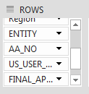

**Remember to filter EC1, 2, 3, 4 under Policy Breach Column.** You may refer to**Tips ad tutorial while using Pivot.docx**to find ways to obtain a table looks like below:

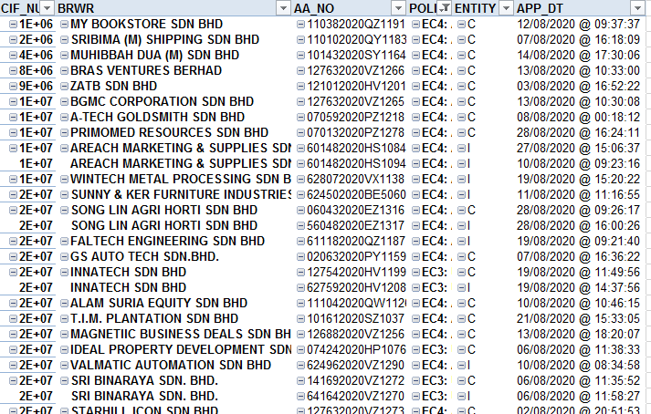

Paste it to the template

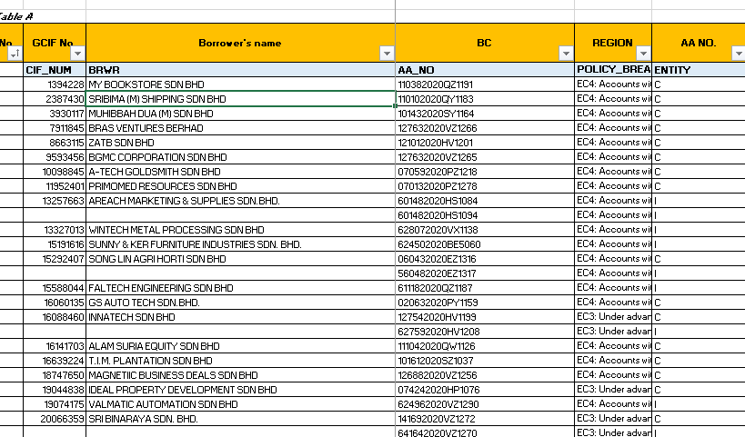

Rearranged the data according to the heading of template.

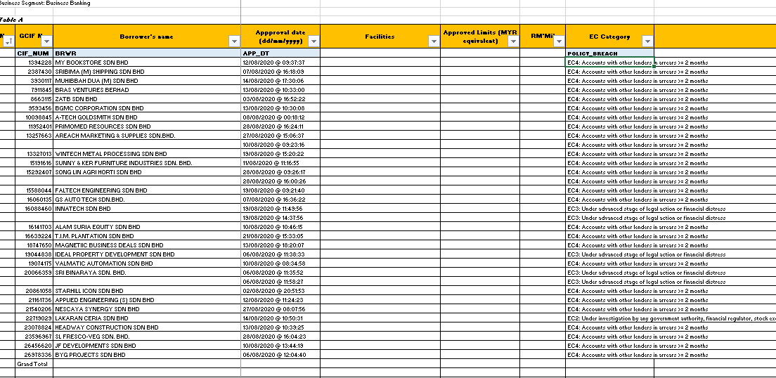

Finally, removed the heading row from Pivot:

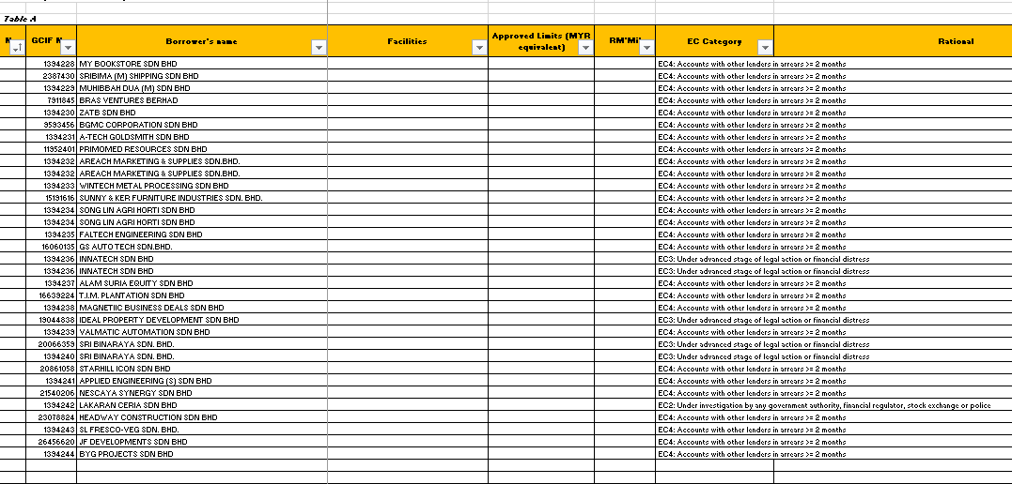

It should look like pic above.

You may found that the column of Facilities, Approved Limit, RM’Mil & Fresh/Add/Renew(Nature of Application) are empty.

You can get these data from: *BB RISK\New House\CRD\2020\08. Aug 2020\raro\PB* *ADH201700589 AA Approved Monthly*

1. **AA Approved Monthly**

In this file, you can obtain 3 column info: Facilities, Status Fresh/Add/Renew approve limit and RM Mil

2.1 You can get Status Fresh/Add/Renew by mapping it with vlookup.

You may refer to Excel Functions Dictionary.docx by CTRL+ Left Click for more detail

The formula in this case is:

=vlookup (AA number cell in **template**, Range from “AA Number column” to “Nature of Application column” in **AA Approved Monthly**, The number of column between AA number column and Nature of Application column, 0)

2.2 For the facilities, we need to put all facilities types and approve limit for each facilities in cell for filter and pivot purpose later, as shown as:

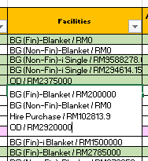

To achieve the purpose, you may follow the steps listed at Method of Put multiple info into 1 cells.docx

2.3 For the approve limit, pivot the data in AA Approved limit. Put AA Number in column box and approve limit in value box. This is to sum out of approve limit for each AA Number. Then in RM Mil, divide the approve limit by formula = approve limit/ 1000000.

Additional Field to map

*To map the Region manually from file: *BB RISK\Code\BC & Region EOS*

*To map the Account Status(PL,WL, SMA, EWS,GIL) for the month from file:

a) PL from file Master BB Funded Non Funded. File: *BB RISK\Master BB\Master BB 2021\Master BB Funded Non Funded*

b) SMA WL EWS from file: *BB RISK\Master BB\Master BB 2021\Month\TF02(Task Force)*

c) GIL from file *BB RISK\Master BB\Master BB 2021\Month\GIL by BC*

d) Date Classified of EC = Approval Date

e) Date Settled - Blank

f) Date monitoring end - Blank

g) Month – Jan 12, Feb 12…. (AA approved for the month)

h) GRCP's queries – Blank

i) Remarks – Blank

j) Status (Map the latest status for Status PL/SMA/WL/EWS, GIL) – This is for the previous borrowers to know the latest status in the Master Listing)

k) EC Yes/No - Blank

1. **EC Comment Only Monthly Final (To map the Rational)**

The data is store at *BB RISK\New House\CRD\2020\08. Aug 2020\raro\PB* *EC Comment Only Monthly Final*

Pivot to summarize the data. In the Column Box put “AA number” and “Rationale”. By using vlookup, map the rationale to the template by using AA number.

You may refer to Excel Functions Dictionary.docx by CTRL+ Left Click for more detail

The formula in this case is:

=vlookup (AA number cell in **template**, Range from “AA number column” to “Rationale column” in **EC Comment Only Monthly Final.** The number of column between AA number column and Rationale column”, 0)

Remember to use F4 to lock the Range from “First AA number cell” to “last rationale cell” in AA Approved Monthly”

You may refer to Z:\BB RISK\Policy Execptional and Credit Policy Deviations\1. EC\EC Quarterly 2020\July 2020\BB Exceptional Credit July 20-Mag Checking.V1.xlsx as a reference to a completed task.

Please be noted that some of the AA has more than 1 rationale, for example: 

Please pivot the data with AA number, Name and rationale to identify which AA has more than 1 rationale, and vlookup with your template to ensure whether there is any AA in the template has encounter this problem.

If so, please manually add other rationale.

After the table is completed, you may start the massaging:

1. **Massaging:**
2. Always remember to exclude account that fulfil criteria mentioned in the exemption list **before removing borrowers.** (For checking whether the borrowers is under EC or not)
3. For the removed borrower, please keep it as backup.

Eg: EC3 can be exempted if it is under summon served status.



** (Please refer to BB RISK\Intern\BBRM\Job Assigned\SOP\SOP Job\SOP\ Exceptional Criteria for EC for more detail about exemption criteria.)-This is for checking purpose whether the borrower is EC or not)

1. When BRWR and Policy Breach are the same with previous period
2. Removed latest “BRWR” and “EC”, but replace previous “BRWR’s approved limit” with latest one.
   * + Eg. Ali Sdn Bhd breached EC 1 in Jan 20, with approved limit RM 1 mil. In May 20, Ali Sdn Bhd breached EC 1 again but approved limit is RM 2 mil. Than removed Ali Sdn Bhd in May 20 and change approved limit at Jan 20 to RM 2 mil.

Eg.

|  |  |  |  |  |
| --- | --- | --- | --- | --- |
| **No** | **BRWR** | **Month** | **App Limit** | **EC- Adj** |
| 1 | AIROD AEROSPACE TECHNOLOGY SDN.BHD. | Sep-19 | ~~8,230,000.00~~ | EC 4 |
| ~~2~~ | ~~AIROD AEROSPACE TECHNOLOGY SDN.BHD.~~ | ~~Apr-20~~ | 7,530,000.00 | ~~EC 4~~ |

***Remove the entire No 2 account, but replace App Limit of Sep 19 (8.23 Mil) with RM 7.53 Mil from Apr 20.

Eg.

|  |  |  |  |  |
| --- | --- | --- | --- | --- |
| **No** | **BRWR** | **Month** | **App Limit** | **EC - Adj** |
| 1 | AIROD AEROSPACE TECHNOLOGY SDN.BHD. | Sep-19 | 8,230,000.00 | EC 4 |
| 2 | AIROD AEROSPACE TECHNOLOGY SDN.BHD. | Apr-20 | 7,530,000.00 | EC 5 |

Number of borrower: 2-1=1

*******Keep both account, but remove 1 borrowers count when counting total number of borrowers.

1. When BRWR Policy Breach are the same with previous period, but one conventional and one Islamic.
   1. Keep the borrower in the list, but do remember to prevent double count of borrowers when counting ratio.
      * Eg. In Jan 20, Ali Sdn Bhd breached EC4. In May 20, Ali Sdn Bhd breached EC5. Keep both account, but removed 1 borrowers when calculating the EC ratio.

|  |  |  |  |  |  |
| --- | --- | --- | --- | --- | --- |
| **No** | **BRWR** | **Entity** | **Month** | **App Limit** | **EC - Adj** |
| 1 | Ali | I / C | Sep-19 | 8,230K +7,530K | EC 4 |
| ~~2~~ | ~~Ali~~ | ~~C~~ | ~~Apr-20~~ | ~~7,530K~~ | ~~EC 4~~ |

1. **Ratio Calculation**

|  |  |  |  |  |  |  |  |  |  |  |  |  |  |  |  |  |  |  |
| --- | --- | --- | --- | --- | --- | --- | --- | --- | --- | --- | --- | --- | --- | --- | --- | --- | --- | --- |
|  | | | | | | | | | |  |  |  |  |  |  |  |  |  |
| cid:image005.png@01D4E942.E1F01CF0 | | | | | | | | |  |  |  |  |  |  |  |  |  |  |
| |  | | --- | |  | | | | | | | | | |  |  |  |  |  |  |  |  |  |  |
|  | | | | | | | | |  |  |  |  |  |  |  |  |  |  |
|  | | | | | | | | |  |  |  |  |  |  |  |  |  |  |
| Example for Apr’19 to June ‘20:  **Calculation Ratio for No. of Borrowers:**  Total No. of EC Borrowers/Total No. of Borrowers In BB Segment  = 219/7638  = 2.87%  **Calculation Ratio for Approved Limit**  Total EC Approved Limit/Total BB Approved Limit  = 1,503.49/49,733.48  = 3.02%  Approved Limit from Susen’s Data(OD, OD Credit Balance), Daniel (TL,Trade & STRC). | | | | | | | | |  |  |  |  |  |  |  |  |  |  |
|  |  |  |  |  |  |  |  |
| *SharedFolder Filestor : BB RISK\BB DATA\2020\8. Aug 2020\MIS* | | | | | | | | |  |  |  |  |  |  |  |  |  |  |
| 1. ODTL FY1112 SMF Product Table 2. ODCr Bal 1011 Product Table 3. 2020-08 Trade Emplacement Authorized Limit 2020 4. 2020-08 BB TL (for Yan May) 5. USD TL   To key in GRCP’s final template in Table B & Table C  **Table B**  Filter EC1, EC2, EC3, EC4 from Master Listing April 19 to Aug 20 to get the No. of Borrowers & Approved Limits  **Table C**   1. Filter EC for the quarter to get no. of borrowers & Limits 2. Key in the total ECs approved since 1 April 2019 until the latest month & Approved Limits 3. Key in the Total borrowers in BB segment & Approved Limits 4. EC Ratio ( per table above under Ratio Calculation)   **Calculation Ratio for No. of Borrowers:**  Total No. of EC Borrowers/Total No. of Borrowers In BB Segment  = 219/7638  = 2.87%  **Calculation Ratio for Approved Limit**  Total EC Approved Limit/Total BB Approved Limit  = 1,503.49/49,733.48  = 3.02%   1. Filter the EC classified as EWS, WL, SMA, Impaired for the quarter and key in no. of borrowers & Approved Limits 2. Ke in the Total ECs classified as EWS, WL, SMA, Impaired from 1 April 2019 until latest month for no. of borrowers & Approved Limits. | | | | | | | | |  |  |  |  |  |  |  |  |  |  |
|  | | | | | | | | |  |  |  |  |  |  |  |  |  |  |
|  | | | | | | | | |  |  |  |  |  |  |  |  |  |  |
| *Please be ensure that approve limit for same borrower should only count once. | | | | | | | | |  |  |  |  |  |  |  |  |  |  |
|  | | | | | | | | |  |  |  |  |  |  |  |  |  |  |

Example:

|  |  |  |
| --- | --- | --- |
| Borrower | EC | Approve Limit |
| Ali | 2 | RM1 |
| Ali | 3 | RM1 |

Please count the A/L for Ali as RM1 instead of RM2

Please count Ali as 1 borrower instead of 2 borrower when calculating ratio